I need to figure out how to acquire or build something that can function as both:

- A workbench for repairing/tinkering with hardware and electronics, etc.
- A desk I can comfortably sit at for regular computer use.

That means it needs to fit these requirements:
- No more than 47” wide, any more and I’m afraid I won’t be able to open the closet door
- Correct height to sit at with a desk chair
- Room for legs to go under the desk
- Room for PC underneath
- Room for monitor on it but preferably mounted somehow
- Power strip or power outlets, preferably across the back bottom
- Plenty of empty surface area

BONUS
- Lighting, preferably above
- Storage for tools and parts

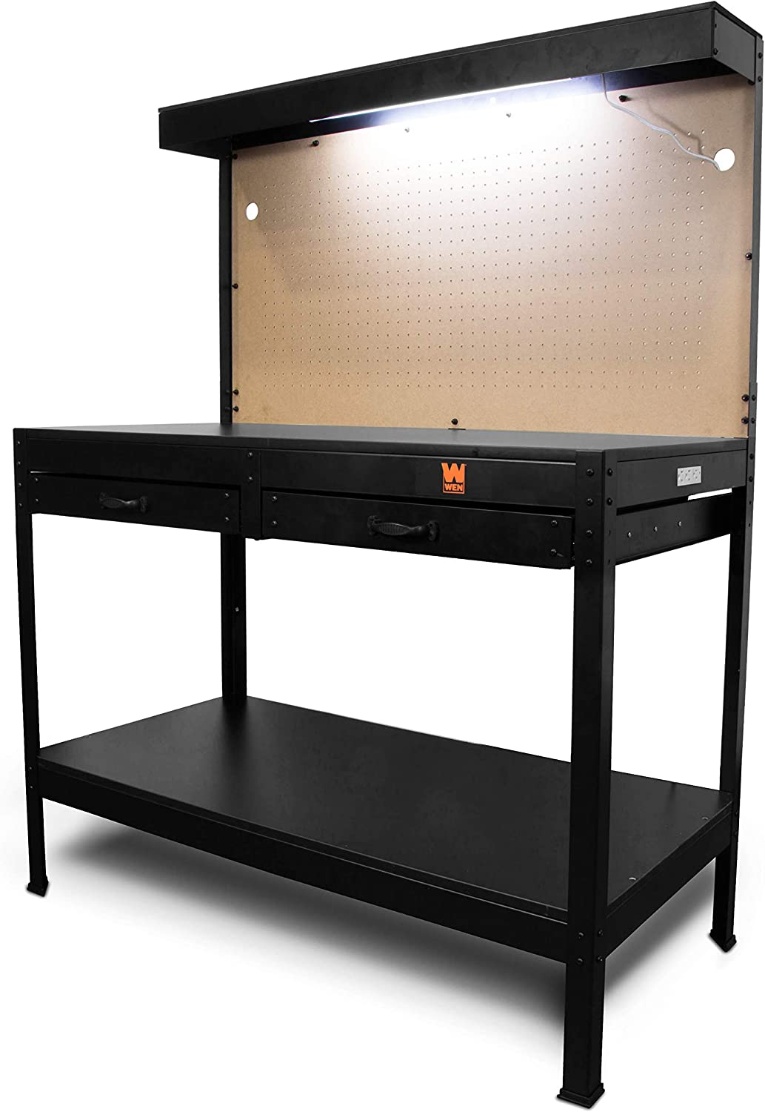

Originally I was planning to get this ($150, $200 with craft cabinet) and I might still settle on this, it is really nice, but there is no room for my legs and I don’t know if it’s the correct height. I’m also not sure where the monitor would go. I don’t really need the giant pegboard either: WEN WB4723T 48-Inch Workbench with Power Outlets and Light

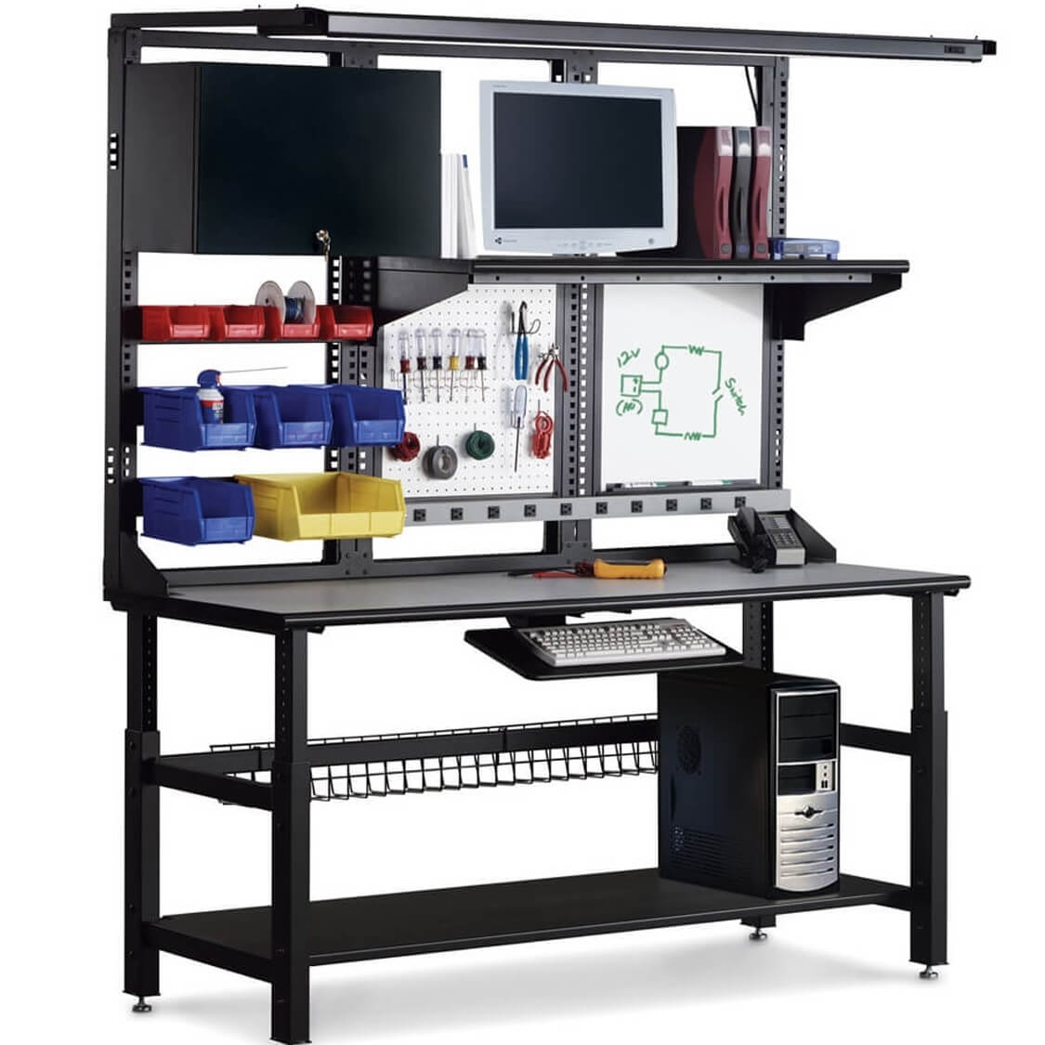

THIS is really cool, unfortunately for some reason it’s OVER $5000! I will have to figure out a cheaper option, but this is in the spirit of what I’m looking for. It has a power strip, space and storage for tools and parts, and accommodates a desktop computer: Craftsman Mobile Worktable

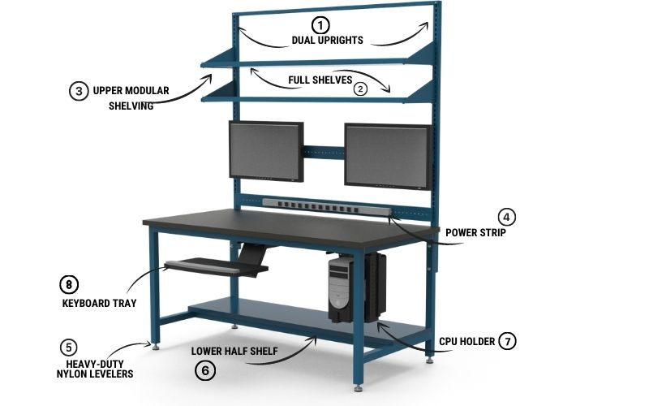
This is a company that makes custom IT/LAN workbenches for businesses. I don’t know what the price is but it’s probably really expensive, and I am not a business, so this is just another example. I like how there is a shelf on the bottom but it’s short so my legs still have room, and I like how the monitors are mounted leaving plenty of surface area. Also it has a power strip. I don’t know what the shelves on the top are for: IT/LAN Workbenches

As I am struggling how to google what I’m looking for, this website also provides useful keywords:
- LAN Workstation
- IT Table
- Computer Workbench
- Computer Table
- LAN Table
- Tech Workstation
- Compuer Desk
- IT Desk
- LAN Station
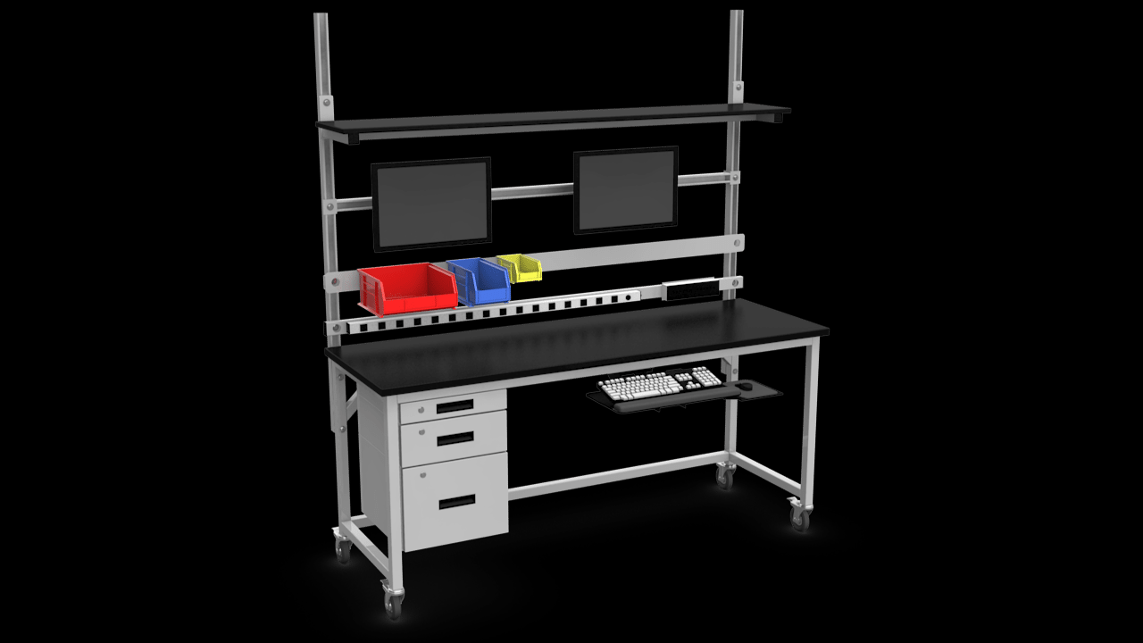
This website has more examples (scroll through the images), another company that makes custom IT/LAN workstations for businesses, I just want something LIKE this, it doesn’t need to be any of these specifically, even if I just get help building it: IT/LAN Workstation

DIY Videos:
Ultimate Electronics Station Build - says he put this together for $300, and mine would be much smaller
How to Build a Cable-Free Desk with Built-In Lights, USB, Outlets + More! - this one is also really cool, monitor is mounted which leaves lots of surface area for projects and it has a top shelf
Here is a normal desk that is an improvement over my current one, but still too wide: https://www.amazon.com/Tribesigns-Computer-Industrial-Workstation-Bookshelf/dp/B08Y5BWQG3/ I like that the monitors are not on the desk itself, providing more space for projects.
